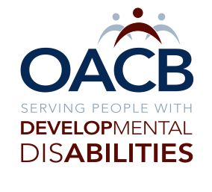
Threshold of Work
Ally Action Plan

Name:
I have a ____________________________________“Heart”

This is how I will use my “Heart” at work:

Wearing my Green Hat at work:
You will “SEE”

You will “HEAR”

This is how I will use the 5 “Must Haves”
Time:

Space:

Positive Tone & Words;

Empathy: Living in Their Shoes

Respectful Relationship

My To Avoid or My Never

My To Do’s or Always

Using My Head to Toe Tools
Name:

My head to toe self-assessment related to enhancing the lives of people receiving & providing services in the Developmental Disabilities Profession.

Thoughts:

Eyes:

Ears:

Words:

Heart:

Hands:

Time:

Feet:

